Worksheet 1 Recursive algorithms Answers
Task 1

1. Write pseudocode for a recursive routine to find the sum of all the even numbers between 0 and n. Show how the subroutine would be called and the result output.

#sums the even numbers from 0 to n
SUB calcSum(n):
IF n > 0 THEN
n n + calcSum(n - 2)
ENDIF
RETURN n
ENDSUB

sum calcSum(10)
OUTPUT sum

2. Trace through the following program. How many times is the recursive routine called? What is output?
Note: numbers[1:] is the list of numbers starting at index 0, i.e. if numbers = [3,6,2,8] then numbers[1:] = [6,2,8]

SUB addNums(numbers)
IF length(numbers) > 1 THEN
numbers[0] = numbers[0] + addNums(numbers[1:])
ENDIF
OUTPUT (numbers[0])
RETURN numbers[0]
ENDSUB

marks = [3,6,2,8]
total = addNums(marks)
OUTPUT ("Total = ", total)

numbers | length(numbers) | numbers[0] | Output
[3,6,2,8] | 4 | 3 + addNums([6,2,8]) | -
[6,2,8] | 3 | 6 + addNums([2,8]) | -
[2,8] | 2 | 2 + addNums([8]) | -
[8] | 1 | 8 | 8
 |  |  | 10
 |  |  | 16
 |  |  | 19
 |  |  | Total = 19

The output is as follows:
8
10
16
19
Total = 19

(See Python and VB program sumList (recursive).py

Task 2
3. A tree is shown below.
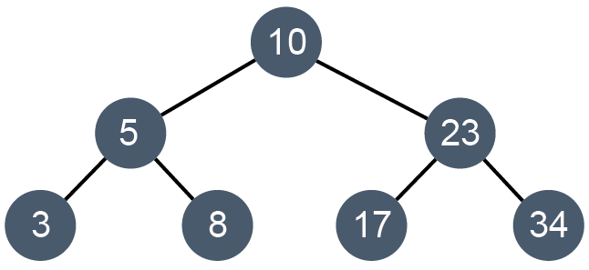
(a) The tree can be represented as a table as shown below. Complete the table to show all left and right pointer values.

 | left | data | right
tree [0] | 1 | 10 | 3
tree[1] | 2 | 5 | 5
tree[2] | -1 | 3 | -1
tree[3] | 6 | 23 | 4
tree[4] | -1 | 34 | -1
tree[5] | -1 | 8 | -1
tree[6] | -1 | 17 | -1
(b) The subroutine for a traversal is shown below. In what order are the nodes output?
SUB traverse(p)
IF tree[p].left <> -1 THEN
traverse(tree[p].left)
ENDIF
OUTPUT tree[p].data
IF tree[p].right <> -1 THEN
traverse(tree[p].right)
ENDIF
ENDSUB
(c) Write a subroutine for a post-order traversal.

SUB postOrderTraverse(p)
IF tree[p].left <> -1 THEN
traverse(tree[p].left)
ENDIF
IF tree[p].right <> -1 THEN
traverse(tree[p].right)
ENDIF
OUTPUT tree[p].data
ENDSUB

4. (a) Operators and operands in a mathematical expression can be added to a tree in such a way that when the tree is traversal using a post-order traversal, an expression is produced in postfix notation. This transformation is typically done during compilation of a program.
Show the output of the following tree when the post-order traversal is performed.
5 3 + 6 2 - *

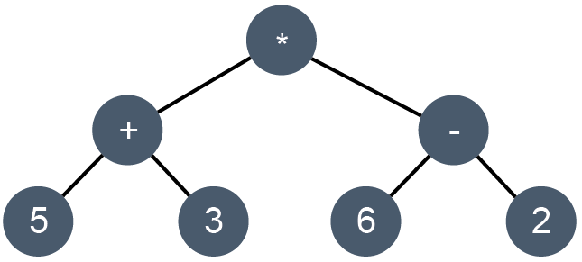

(b) An expression in prefix notation is produced when the tree is traversed using the following traversal algorithm:

visit the root node
traverse the left subtree
traverse the right subtree

Show the output of the tree when the pre-order traversal is performed.
* +5 3 – 6 2
(c) Perform an in-order traversal and hence evaluate the expression.
(5 + 3) * (6 – 2) = 8 * 4 = 32

